**BE-CSE (Artificial Intelligence)**

**(3rd Year)**

**PROJECT SYNOPSIS**

**Gesture Speak: Sign Language Translator**

**SUBMITTED BY:**

**Harshit Behl (2110993788)**

**Himanshu Dhingra (2110993793)**

**Ojas Chawla (2110993820)**

**Guided by**

**Mr. Deepak Kumar & Mr. Sahil Garg**

**CHITKARA UNIVERSITY INSITUTE OF ENGINEERRING & TECHNOLOGY**

**CHITKARA UNIVERSITY, RAJPURA**

**August 2023**

**PROBLEM STATEMENT**

The problem at hand is the lack of an accessible and reliable means of communication between Deaf and hard-of-hearing individuals who use sign language and those who do not understand it. Traditional methods of communication, such as pen-and-paper or basic gestures, often fall short in conveying complex messages accurately and efficiently.

**INTRODUCTION**

The "Sign Language Video Translator" project aims to bridge the communication gap between Deaf and hard-of-hearing individuals who use sign language as their primary mode of communication and those who do not understand sign language.

* A Computer Vision & Natural Language Processing based program using deep learning to detect and translate sign language and gestures.
* Helps in establishing seamless communication between sign language users and speakers of spoken language.
* Hence helping in playing a pivotal role in making education and job opportunities more accessible.

**TECHNOLOGY**

* Python

The entire project is developed in python. It serves as the foundation for implementing various modules, handling data, and orchestrating the interaction between different components.

* Scikit-Learn

It will be used for tasks such as feature extraction, data preprocessing, and training models to recognize and interpret sign language gestures.

* Natural Language Toolkit

It will be used to assist in processing and generating textual output based on the interpreted gestures.

* Spacy

It will be used for part-of-speech tagging, named entity recognition, and other linguistic analyses that will be relevant in generating accurate natural language translations from sign language gestures.

* OpenCV

It is a computer vision library used for image and video processing tasks. It will be used in detecting and tracking hand gestures and movements from video input.

* TensorFlow & Keras

TensorFlow is a deep learning framework, and Keras is an API that runs on top of TensorFlow. These tools could be utilized for building and training neural network models to recognize specific sign language gestures from video frames.

* Flask

It would be used to create a user-friendly web interface for users. Flask would handle the communication between the user and the backend processing components.

**FLOWCHART**

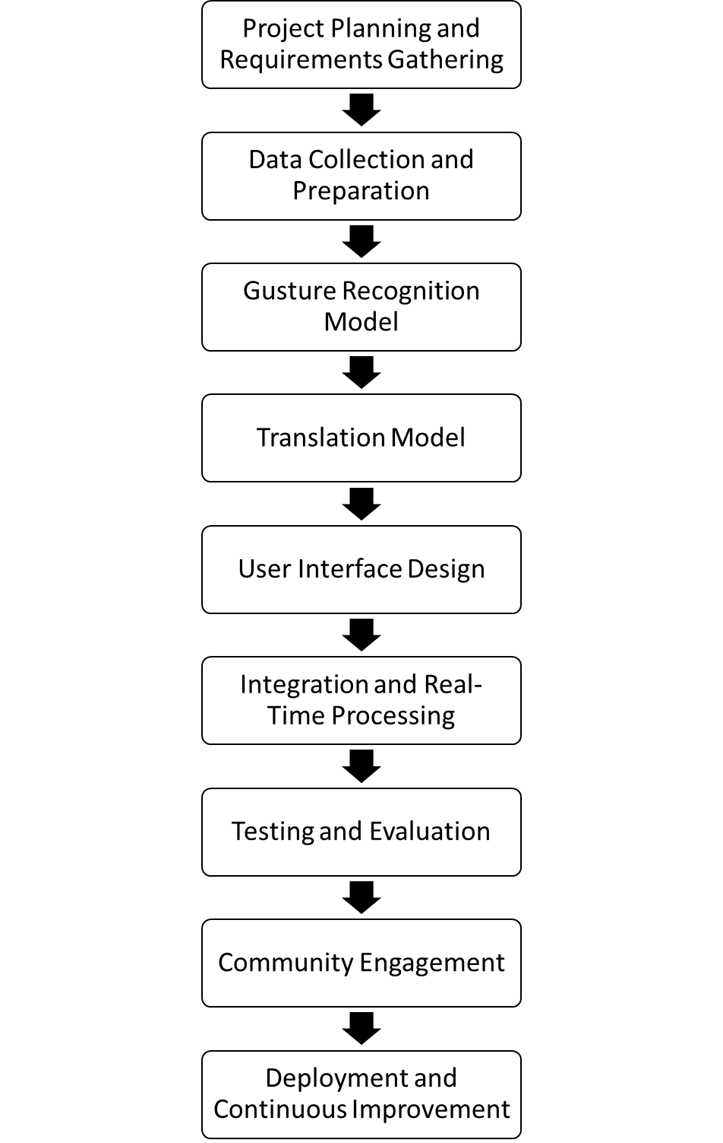

**CONCLUSION**

Gesture Speak: Sign Language Translator" project embodies a groundbreaking fusion of machine learning, computer vision, and natural language processing to address the communication gap between sign language and spoken language.

The project aims to recognize intricate sign language gestures with precision. The application of OpenCV empowers the system to adeptly track and decipher hand movements in real-time video streams. Moreover, the utilization of TensorFlow and Keras equips the project with the capabilities to develop and fine-tune neural networks that can effectively learn and decode sign language expressions.

By providing a dynamic solution that not only recognizes sign language gestures but also encapsulates their nuanced meanings in natural language text, the project envisions a future where communication transcends boundaries and fosters greater understanding and inclusivity among individuals of varied linguistic backgrounds.